Corona Plateau Mauritius
Newsletter April 2022
The AGM took place at the Gymkhana Club on the 18th March. Twenty members were present and the Chairwoman, Rosemarie, gave her report on the past year’s activities, followed by the Treasurer’s report. As there were no questions following these reports, the voting of the incoming committee followed. It had been decided that the outgoing committee members should continue for the year 22/23, as many months had not seen any acitivities due to Covid 19 restrictions. As there were no further nominations for committee members, the following were elected to form the committee for 1922/23: Rosemarie Domaingue, Lyndsay Riviere, Kamini Basant, Asha Putty, Mira Hurbungs and Lata Domun. Neena Misri, Manda Boolell and Huguette Legris have agreed to continue as advisors. We thank all the above for accepting to continue to serve the Corona Plateau. Welcome back to Neena after many months of absence due to travel restrictions caused by Covid.
We were very pleased to welcome a group of five ladies who came and gave a demonstration of Irish dancing to honour St. Patrick’s day, which was on the 17th March. This was an extremely dynamic and lively group and many of our ladies joined in the dancing at the end. The morning was enhanced by posters relating to Irish activities and some glorious headwear which were kindly loaned by Yvonne Koo, who was invited by Lyndsay to join us for the morning.
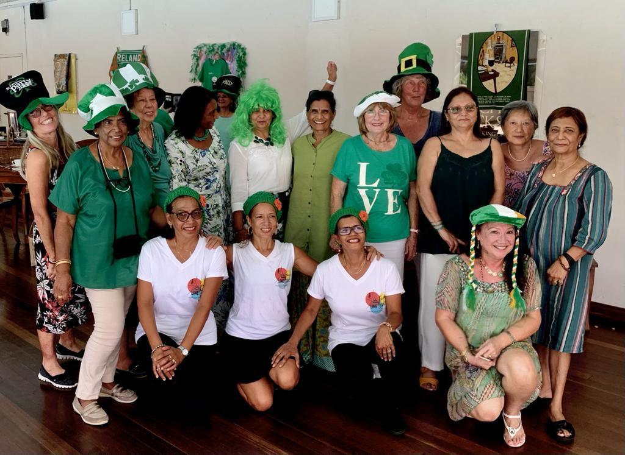
Several ladies stayed on and enjoyed lunch on the terrace by the swimming pool, which rounded off a very busy morning. All the above activities took place in a very friendly and relaxed atmosphere, and it was very gratifying to see so many happy and smiling ladies enjoying each others company. Emilie rounded off her morning by winning the raffle prize, a tealight holder for outdoor use. Well done, Emilie.
The committee subsequently met to determine the various posts to be held and it was decided :
Chairwoman: Asha Putty- 58274055
Treasurer: Rosemarie Domaingue- 57215286
Secretary: Kamini Basant- 57557266
Events and communications: Lyndsay Riviere- 57774351
Newsletter: Rosemarie Domaingue
Members: Mira Hurbungs-57777718, Lata Domun- 59807208
Advisors: Manda Boolell,-54237476 Huguette Legris-57957750, Neena Misri -54215503
The signatories at the Floreal Branch of the MCB will be Rosemarie Domaingue, Lyndsay Riviere and Kamini Basant.
PLEASE NOTE THAT THE APRIL MEETING WILL BE HELD ON FRIDAY 15th APRIL. (GOOD FRIDAY)
This meeting will have an Easter theme, Watch this space for details.

We have a few announcements to make:
The group of dancers meet at the St. Clement’s Church hall in Curepipe. Any lady wishing to join them for fun and exercise is welcome. Contact Maureen for details.
French lessons: Would any lady interested in taking French speaking lessons in a small group please contact Lyndsay on 5777435 for details.

Some of you may have been to the Corona evenings organised at Patricia Mohamed’s house in Vacoas. These were magical moments and highlights of end of year celebrations a few years back. Mael and Patricia have asked us to let you know that the house is now for sale, and to visit or get more details, Mael’s mobile number is 52530708. The garden is fully planted with exotic flowers and fruit trees, and the house is a four bedroom classical style house . Well worth a visit if you are house hunting.
For your information:
The dates of the year’s meetings are as follows:
April 15, May 20th, June 17th, July 15th, August 19th, September 16th, Oct 21st, November 18th, December 16th, January 20th, February 17th, March 17th.
Please mark them in your diary, but we shall be reminding you each month in the newsletter.

