Corona Plateau Mauritius
Newsletter February 2022
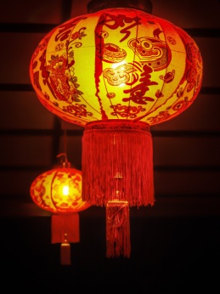
Kung Hee Fat Choy to you all.

Hopefully February will bring some normality back into our lives. The pandemic rages on, but hopefully is under control, especially if we observe the restrictions and conditions when socialising and going out. In this light, we have decided to hold our February meeting at the Gymkhana Club as usual on the 3rd Friday of the month, that is the 18th, at 10.30 am. We do hope to see many of you there.
Some time ago, we were given some craft materials by Mrs. Janet Ribet. This donation was channelled by Mandy Teelock, and it was decided that Lyndsay would use them with the pupils of Trinity Centre in Rose Hill. They did use some stencils and inks, but they found them quite complicated to use. We have now decided to raise some funds for the club by selling these articles on to those ladies who are interested in doing craft work in their homes. Therefore during our February meeting, Lyndsay and Mandy will bring them to the Gymkhana. You may bring any friends who may be interested in seeing the materials, but please remind them that the Club does require all visitors to be fully vaccinated and bring proof of that with them.
Our January meeting took the form of a coffee morning at Rosemarie’s house. Some 14 ladies were present, and in spite of the rain, we all had a good time catching up with each other after such a long time. Thanks to all the ladies who contributed to making the morning a success.
During the next meeting, we shall also discuss the AGM, which will take place on the 18th March at the Gymkhana Club at 10.30 am. Any one wishing to sit on the committee for 2022/23 is welcome.

Looking forward to seeing you
Your committeee

